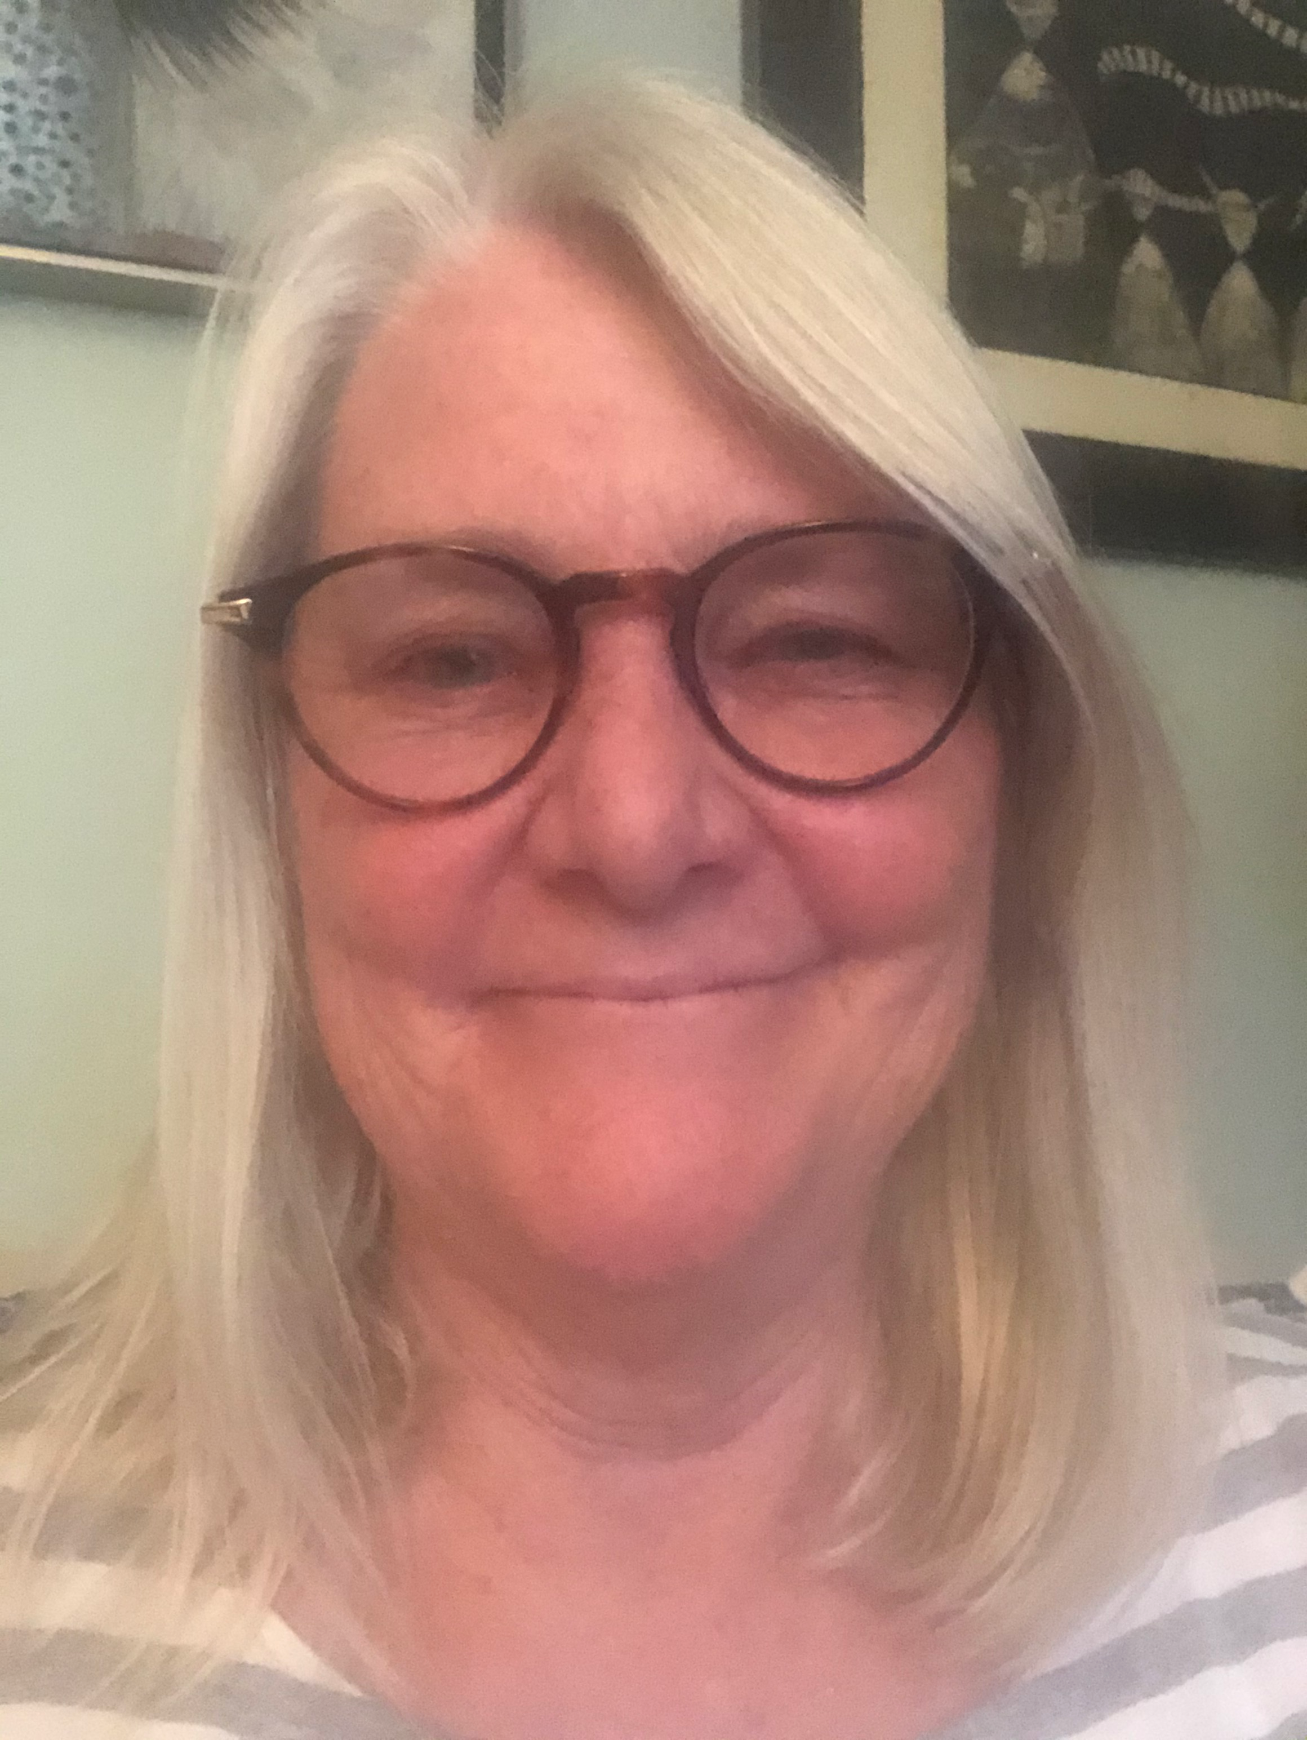
Linda Zidonik
Mosaic Artist
LindaCZi@aol.com
352-262-7278

I am a mosaic artist in Gainesville, Florida. About 24 years ago I found my passion in mosaics when I attended a mosaic school in Ravenna, Italy in 2001 and steadily my passion has grown. I love the challenges of painting with the hard edges of glass, the sound of the glass cutter, the obsessive thrill of lining up the tesserae. My work can be found at Melrose Bay Gallery and Gainesville Fine Arts Association. I have a studio at the Art Studios of Grace, 3146 NW 13th Street Gainesville which I share with mosaic enthusiasts who want to work on their own projects with help, Tuesdays and Thursdays from 6-9pm. I also teach small classes on demand.

Recognitions
GFAA- work of merit, Summer Showcase, 2021, Award of Excellence-2024
The Gainesville Magazine, featured article, Nov.-Dec., ‘09
Harn Art Museum, Gainesville, Fl. Artist in Residence, 10-‘08
The Gallery, WUFT featured artist, April, ’08
Galleries and Shows
McIntyre’s Stain Glass Gallery, Gainesville, ’07-22
Somewhere Along The Way Gallery, Gainesville, 15-17
Butterfield Gallery, St. Augustine, Fl.-2015-2016
National Mosaic Exhibition on the Cape, Cape Cod, Mass. ‘11
Global Priorities Exhibition, Miami Mosaic Academy, Miami, Fl. Nov. ’09-Jan. ‘10
The Randy Batista Gallery, Gainesville, Fl. Jan-Feb.’09, Oct. ‘10
Smith Museum of Art Gift Store, Northampton, Ma. ‘09
Hippodrome State Theater Gallery, Nov. ‘08
Sidewalk Art Shows
Downtown Arts Festival, Gainesville, Fl. Nov. ’96-‘16
Morristown Craft Market, Morristown, NJ, Oct. ‘09
Paradise City Art Show- Northampton, Mass. May ’08-‘09
St. Stephen’s Art & Craft Show, Coconut Grove, Fl. Feb. ‘07
Kanapaha Garden show, ’99 and ’06

Installations
Whole Foods Mosaic Fountain Fall 2018
Dr. and Mrs. Marichal-2015- Kitchen backsplash
Fresh Hair-Boston Logo- exterior entrance- 2015
Themeworks- Exterior signs for Sea World, exterior sign for Busch Gardens,
2011-2012
Brytan Sundial- 2010

